Quotes Design
![Quotes]
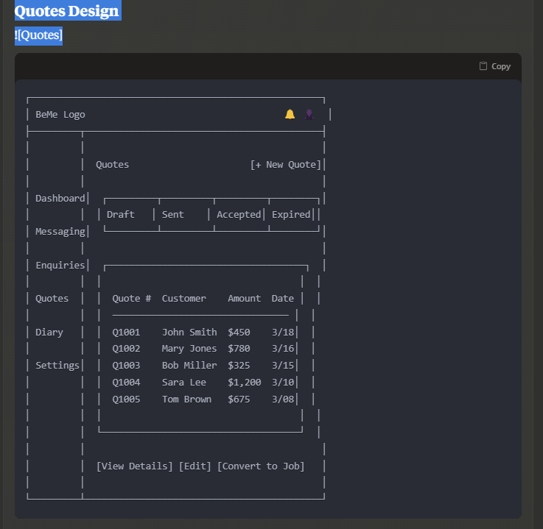

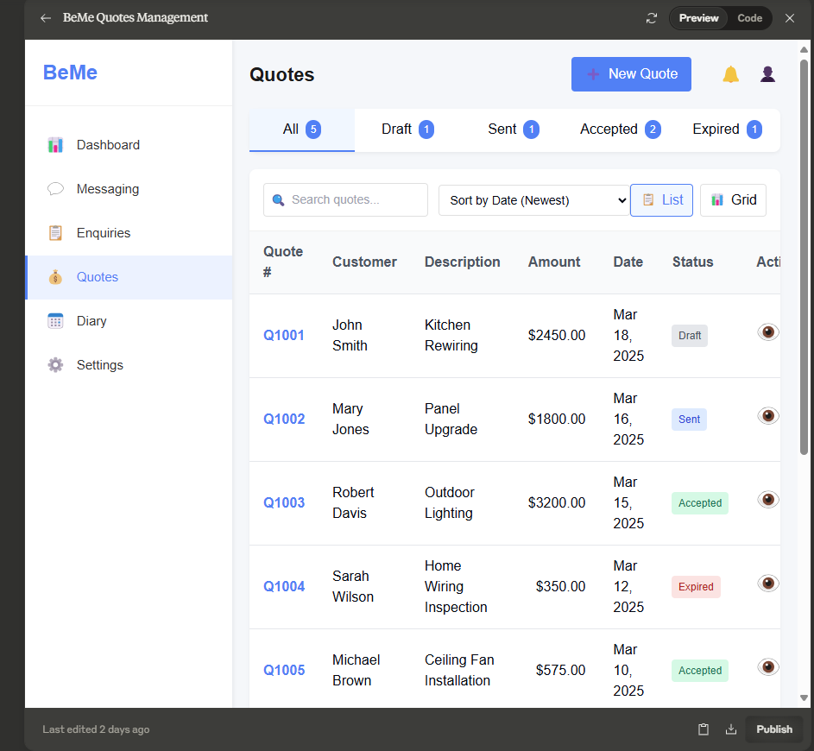

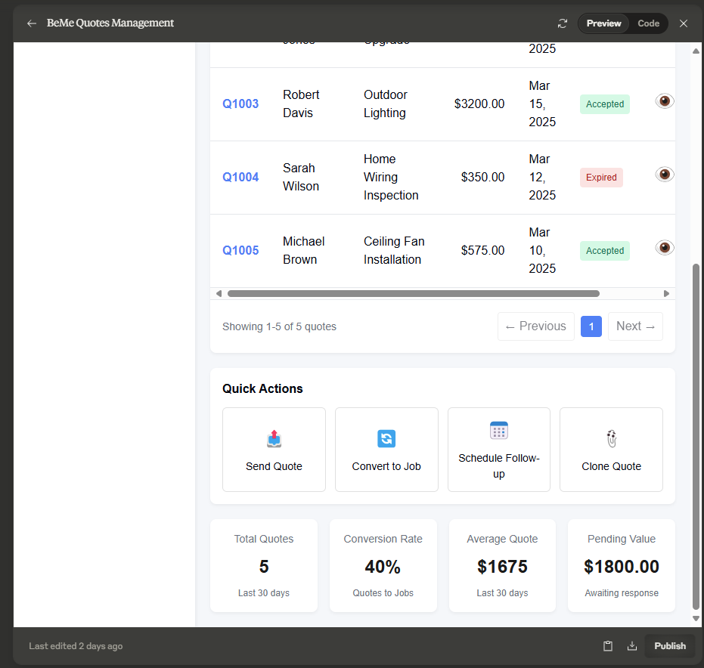

import React, { useState } from 'react';

const Quotes = () => {
const [activeTab, setActiveTab] = useState('all');
const [selectedQuote, setSelectedQuote] = useState(null);

// Sample quotes data
const quotes = [
{
id: 'Q1001',
customer: 'John Smith',
description: 'Kitchen Rewiring',
amount: 2450.00,
date: 'Mar 18, 2025',
status: 'draft'
},
{
id: 'Q1002',
customer: 'Mary Jones',
description: 'Panel Upgrade',
amount: 1800.00,
date: 'Mar 16, 2025',
status: 'sent'
},
{
id: 'Q1003',
customer: 'Robert Davis',
description: 'Outdoor Lighting',
amount: 3200.00,
date: 'Mar 15, 2025',
status: 'accepted'
},
{
id: 'Q1004',
customer: 'Sarah Wilson',
description: 'Home Wiring Inspection',
amount: 350.00,
date: 'Mar 12, 2025',
status: 'expired'
},
{
id: 'Q1005',
customer: 'Michael Brown',
description: 'Ceiling Fan Installation',
amount: 575.00,
date: 'Mar 10, 2025',
status: 'accepted'
}
];

// Filter quotes based on active tab
const filteredQuotes = activeTab === 'all'
? quotes
: quotes.filter(quote => quote.status === activeTab);

return (
<div className="app-container">
{/* Sidebar */}
<div className="sidebar">
<div className="logo-container">
<div className="logo">BeMe</div>
</div>
<div className="sidebar-menu">
<div className="menu-item">
<div className="menu-icon">📊</div>
<div className="menu-text">Dashboard</div>
</div>
<div className="menu-item">
<div className="menu-icon">💬</div>
<div className="menu-text">Messaging</div>
</div>
<div className="menu-item">
<div className="menu-icon">📋</div>
<div className="menu-text">Enquiries</div>
</div>
<div className="menu-item active">
<div className="menu-icon">💰</div>
<div className="menu-text">Quotes</div>
</div>
<div className="menu-item">
<div className="menu-icon">📅</div>
<div className="menu-text">Diary</div>
</div>
<div className="menu-item">
<div className="menu-icon">⚙️</div>
<div className="menu-text">Settings</div>
</div>
</div>
</div>

{/* Main Content */}
<div className="main-content">
{/* Header */}
<div className="header">
<div className="page-title">Quotes</div>
<div className="header-actions">
<button className="new-quote-btn">
<span className="new-icon">➕</span>
<span>New Quote</span>
</button>
<div className="notification-icon">🔔</div>
<div className="user-profile">👤</div>
</div>
</div>

{/* Quotes Tabs */}
<div className="quotes-tabs">
<div
className={`tab ${activeTab === 'all' ? 'active' : ''}`}
onClick={() => setActiveTab('all')}
>
<span className="tab-text">All</span>
<span className="tab-badge">{quotes.length}</span>
</div>
<div
className={`tab ${activeTab === 'draft' ? 'active' : ''}`}
onClick={() => setActiveTab('draft')}
>
<span className="tab-text">Draft</span>
<span className="tab-badge">{quotes.filter(q => q.status === 'draft').length}</span>
</div>
<div
className={`tab ${activeTab === 'sent' ? 'active' : ''}`}
onClick={() => setActiveTab('sent')}
>
<span className="tab-text">Sent</span>
<span className="tab-badge">{quotes.filter(q => q.status === 'sent').length}</span>
</div>
<div
className={`tab ${activeTab === 'accepted' ? 'active' : ''}`}
onClick={() => setActiveTab('accepted')}
>
<span className="tab-text">Accepted</span>
<span className="tab-badge">{quotes.filter(q => q.status === 'accepted').length}</span>
</div>
<div
className={`tab ${activeTab === 'expired' ? 'active' : ''}`}
onClick={() => setActiveTab('expired')}
>
<span className="tab-text">Expired</span>
<span className="tab-badge">{quotes.filter(q => q.status === 'expired').length}</span>
</div>
</div>

{/* Quotes Content */}
<div className="quotes-content">
<div className="quotes-controls">
<div className="search-filter">
<div className="search-box">
<input type="text" placeholder="Search quotes..." />
<span className="search-icon">🔍</span>
</div>
<select className="filter-dropdown">
<option>Sort by Date (Newest)</option>
<option>Sort by Date (Oldest)</option>
<option>Sort by Amount (High to Low)</option>
<option>Sort by Amount (Low to High)</option>
<option>Sort by Customer (A to Z)</option>
</select>
</div>
<div className="view-options">
<button className="view-btn active">
<span className="view-icon">📋</span>
<span>List</span>
</button>
<button className="view-btn">
<span className="view-icon">📊</span>
<span>Grid</span>
</button>
</div>
</div>

<div className="quotes-table">
<table>
<thead>
<tr>
<th>Quote #</th>
<th>Customer</th>
<th>Description</th>
<th>Amount</th>
<th>Date</th>
<th>Status</th>
<th>Actions</th>
</tr>
</thead>
<tbody>
{filteredQuotes.map(quote => (
<tr key={quote.id} onClick={() => setSelectedQuote(quote.id)}>
<td className="quote-id">{quote.id}</td>
<td className="quote-customer">{quote.customer}</td>
<td className="quote-description">{quote.description}</td>
<td className="quote-amount">${quote.amount.toFixed(2)}</td>
<td className="quote-date">{quote.date}</td>
<td className="quote-status">
<span className={`status-badge ${quote.status}`}>{quote.status}</span>
</td>
<td className="quote-actions">
<div className="action-buttons">
<button className="table-action-btn">
<span className="action-icon">👁️</span>
</button>
<button className="table-action-btn">
<span className="action-icon">✏️</span>
</button>
<button className="table-action-btn">
<span className="action-icon">🗑️</span>
</button>
</div>
</td>
</tr>
))}
</tbody>
</table>
</div>

<div className="quotes-pagination">
<div className="pagination-info">
Showing 1-{filteredQuotes.length} of {filteredQuotes.length} quotes
</div>
<div className="pagination-controls">
<button className="pagination-btn" disabled>
<span className="pagination-icon">←</span>
<span>Previous</span>
</button>
<div className="pagination-pages">
<button className="page-btn active">1</button>
</div>
<button className="pagination-btn" disabled>
<span>Next</span>
<span className="pagination-icon">→</span>
</button>
</div>
</div>
</div>

{/* Quick Actions */}
<div className="quick-actions-panel">
<div className="panel-title">Quick Actions</div>
<div className="action-buttons">
<button className="action-btn">
<span className="action-icon">📤</span>
<span className="action-text">Send Quote</span>
</button>
<button className="action-btn">
<span className="action-icon">🔄</span>
<span className="action-text">Convert to Job</span>
</button>
<button className="action-btn">
<span className="action-icon">📅</span>
<span className="action-text">Schedule Follow-up</span>
</button>
<button className="action-btn">
<span className="action-icon">📎</span>
<span className="action-text">Clone Quote</span>
</button>
</div>
</div>

{/* Statistics */}
<div className="quotes-stats">
<div className="stat-card">
<div className="stat-title">Total Quotes</div>
<div className="stat-value">{quotes.length}</div>
<div className="stat-footer">Last 30 days</div>
</div>
<div className="stat-card">
<div className="stat-title">Conversion Rate</div>
<div className="stat-value">
{Math.round((quotes.filter(q => q.status === 'accepted').length / quotes.length) * 100)}%
</div>
<div className="stat-footer">Quotes to Jobs</div>
</div>
<div className="stat-card">
<div className="stat-title">Average Quote</div>
<div className="stat-value">
${Math.round(quotes.reduce((sum, q) => sum + q.amount, 0) / quotes.length)}
</div>
<div className="stat-footer">Last 30 days</div>
</div>
<div className="stat-card">
<div className="stat-title">Pending Value</div>
<div className="stat-value">
${quotes.filter(q => q.status === 'sent').reduce((sum, q) => sum + q.amount, 0).toFixed(2)}
</div>
<div className="stat-footer">Awaiting response</div>
</div>
</div>
</div>

<style jsx>{`
.app-container {
display: flex;
min-height: 100vh;
font-family: 'Inter', sans-serif;
background-color: #f5f7fa;
}

/* Sidebar styles */
.sidebar {
width: 240px;
background-color: white;
box-shadow: 2px 0 4px rgba(0, 0, 0, 0.05);
padding: 20px 0;
display: flex;
flex-direction: column;
}

.logo-container {
padding: 0 20px 20px;
border-bottom: 1px solid #f0f0f0;
margin-bottom: 20px;
}

.logo {
font-size: 24px;
font-weight: bold;
color: #3B82F6;
}

.sidebar-menu {
display: flex;
flex-direction: column;
flex-grow: 1;
}

.menu-item {
display: flex;
align-items: center;
padding: 12px 20px;
cursor: pointer;
transition: background-color 0.2s;
border-left: 3px solid transparent;
}

.menu-item:hover {
background-color: #f5f7fa;
}

.menu-item.active {
background-color: #ebf2ff;
border-left-color: #3B82F6;
}

.menu-icon {
margin-right: 12px;
font-size: 18px;
}

.menu-text {
font-size: 15px;
color: #333;
}

.menu-item.active .menu-text {
font-weight: 500;
color: #3B82F6;
}

/* Main content styles */
.main-content {
flex: 1;
padding: 20px;
overflow-y: auto;
}

.header {
display: flex;
justify-content: space-between;
align-items: center;
margin-bottom: 20px;
}

.page-title {
font-size: 22px;
font-weight: 600;
color: #1a1a1a;
}

.header-actions {
display: flex;
align-items: center;
}

.new-quote-btn {
display: flex;
align-items: center;
background-color: #3B82F6;
color: white;
border: none;
border-radius: 4px;
padding: 8px 16px;
margin-right: 16px;
cursor: pointer;
font-weight: 500;
transition: background-color 0.2s;
}

.new-quote-btn:hover {
background-color: #2563eb;
}

.new-icon {
margin-right: 8px;
font-size: 14px;
}

.notification-icon, .user-profile {
font-size: 20px;
margin-left: 16px;
cursor: pointer;
}

/* Quotes tabs */
.quotes-tabs {
display: flex;
background-color: white;
border-radius: 8px;
margin-bottom: 20px;
box-shadow: 0 2px 4px rgba(0, 0, 0, 0.05);
}

.tab {
display: flex;
align-items: center;
padding: 12px 16px;
cursor: pointer;
border-bottom: 2px solid transparent;
flex: 1;
justify-content: center;
}

.tab:hover {
background-color: #f8faff;
}

.tab.active {
border-bottom-color: #3B82F6;
background-color: #f0f7ff;
}

.tab-text {
font-weight: 500;
}

.tab-badge {
background-color: #3B82F6;
color: white;
font-size: 12px;
padding: 2px 6px;
border-radius: 10px;
margin-left: 8px;
}

/* Quotes content */
.quotes-content {
background-color: white;
border-radius: 8px;
box-shadow: 0 2px 4px rgba(0, 0, 0, 0.05);
margin-bottom: 20px;
overflow: hidden;
}

.quotes-controls {
display: flex;
justify-content: space-between;
align-items: center;
padding: 16px;
border-bottom: 1px solid #f0f0f0;
}

.search-filter {
display: flex;
align-items: center;
gap: 12px;
flex: 1;
}

.search-box {
position: relative;
flex: 1;
max-width: 300px;
}

.search-box input {
width: 100%;
padding: 8px 8px 8px 32px;
border: 1px solid #e0e0e0;
border-radius: 4px;
font-size: 14px;
}

.search-icon {
position: absolute;
left: 8px;
top: 50%;
transform: translateY(-50%);
font-size: 14px;
}

.filter-dropdown {
padding: 8px;
border: 1px solid #e0e0e0;
border-radius: 4px;
font-size: 14px;
}

.view-options {
display: flex;
gap: 8px;
}

.view-btn {
display: flex;
align-items: center;
background-color: white;
border: 1px solid #e0e0e0;
border-radius: 4px;
padding: 6px 10px;
cursor: pointer;
transition: all 0.2s;
}

.view-btn:hover, .view-btn.active {
background-color: #f0f7ff;
border-color: #3B82F6;
color: #3B82F6;
}

.view-icon {
margin-right: 6px;
font-size: 14px;
}

.quotes-table {
width: 100%;
overflow-x: auto;
}

table {
width: 100%;
border-collapse: collapse;
}

th {
text-align: left;
padding: 12px 16px;
font-weight: 600;
color: #4b5563;
background-color: #f9fafb;
border-bottom: 1px solid #e5e7eb;
}

td {
padding: 12px 16px;
border-bottom: 1px solid #e5e7eb;
}

tr:hover {
background-color: #f8faff;
}

.quote-id {
font-weight: 600;
color: #3B82F6;
}

.quote-customer {
font-weight: 500;
}

.quote-amount {
font-weight: 500;
text-align: right;
}

.status-badge {
display: inline-block;
padding: 4px 8px;
border-radius: 4px;
font-size: 12px;
font-weight: 500;
text-transform: capitalize;
}

.status-badge.draft {
background-color: #e5e7eb;
color: #4b5563;
}

.status-badge.sent {
background-color: #dbeafe;
color: #1d4ed8;
}

.status-badge.accepted {
background-color: #d1fae5;
color: #047857;
}

.status-badge.expired {
background-color: #fee2e2;
color: #b91c1c;
}

.quote-actions {
text-align: right;
}

.action-buttons {
display: flex;
justify-content: flex-end;
gap: 4px;
}

.table-action-btn {
background-color: transparent;
border: none;
width: 28px;
height: 28px;
display: flex;
align-items: center;
justify-content: center;
border-radius: 4px;
cursor: pointer;
transition: background-color 0.2s;
}

.table-action-btn:hover {
background-color: #f0f7ff;
}

.action-icon {
font-size: 14px;
}

.quotes-pagination {
display: flex;
justify-content: space-between;
align-items: center;
padding: 16px;
border-top: 1px solid #e5e7eb;
}

.pagination-info {
font-size: 14px;
color: #6b7280;
}

.pagination-controls {
display: flex;
align-items: center;
gap: 8px;
}

.pagination-btn {
display: flex;
align-items: center;
background-color: white;
border: 1px solid #e0e0e0;
border-radius: 4px;
padding: 6px 10px;
cursor: pointer;
transition: all 0.2s;
}

.pagination-btn:not(:disabled):hover {
background-color: #f0f7ff;
border-color: #3B82F6;
color: #3B82F6;
}

.pagination-btn:disabled {
opacity: 0.5;
cursor: not-allowed;
}

.pagination-icon {
font-size: 12px;
}

.pagination-btn:first-child .pagination-icon {
margin-right: 6px;
}

.pagination-btn:last-child .pagination-icon {
margin-left: 6px;
}

.pagination-pages {
display: flex;
gap: 4px;
}

.page-btn {
width: 28px;
height: 28px;
display: flex;
align-items: center;
justify-content: center;
border-radius: 4px;
border: 1px solid #e0e0e0;
background-color: white;
font-size: 14px;
cursor: pointer;
transition: all 0.2s;
}

.page-btn:hover, .page-btn.active {
background-color: #3B82F6;
border-color: #3B82F6;
color: white;
}

/* Quick actions panel */
.quick-actions-panel {
background-color: white;
border-radius: 8px;
box-shadow: 0 2px 4px rgba(0, 0, 0, 0.05);
padding: 16px;
margin-bottom: 20px;
}

.panel-title {
font-size: 16px;
font-weight: 600;
margin-bottom: 12px;
}

.action-buttons {
display: flex;
gap: 12px;
}

.action-btn {
display: flex;
flex-direction: column;
align-items: center;
justify-content: center;
background-color: white;
border: 1px solid #e0e0e0;
border-radius: 6px;
padding: 12px;
flex: 1;
cursor: pointer;
transition: all 0.2s;
}

.action-btn:hover {
background-color: #f0f7ff;
border-color: #3B82F6;
}

.action-icon {
font-size: 24px;
margin-bottom: 8px;
}

.action-text {
font-size: 14px;
font-weight: 500;
text-align: center;
}

/* Statistics */
.quotes-stats {
display: grid;
grid-template-columns: repeat(4, 1fr);
gap: 16px;
}

.stat-card {
background-color: white;
border-radius: 8px;
box-shadow: 0 2px 4px rgba(0, 0, 0, 0.05);
padding: 16px;
text-align: center;
}

.stat-title {
font-size: 14px;
color: #6b7280;
margin-bottom: 8px;
}

.stat-value {
font-size: 24px;
font-weight: 600;
color: #1a1a1a;
margin-bottom: 8px;
}

.stat-footer {
font-size: 12px;
color: #6b7280;
}
`}</style>
</div>
);
};

export default Quotes;
Last edited 2 days ago

